I have used 3 features where it checks below features

* if left word is a alpha numeric.
* if right word is a alpha numeric.
* if left word is a digit.

I have completed my program successfully where it generates 98 percent accuracy for 8 features, 5 given features and 3 made up features. Also, I have generated sbd.test.out file where it displays predicted and actual values and its shows that my program is accurate

Accuracy with all 8 features:

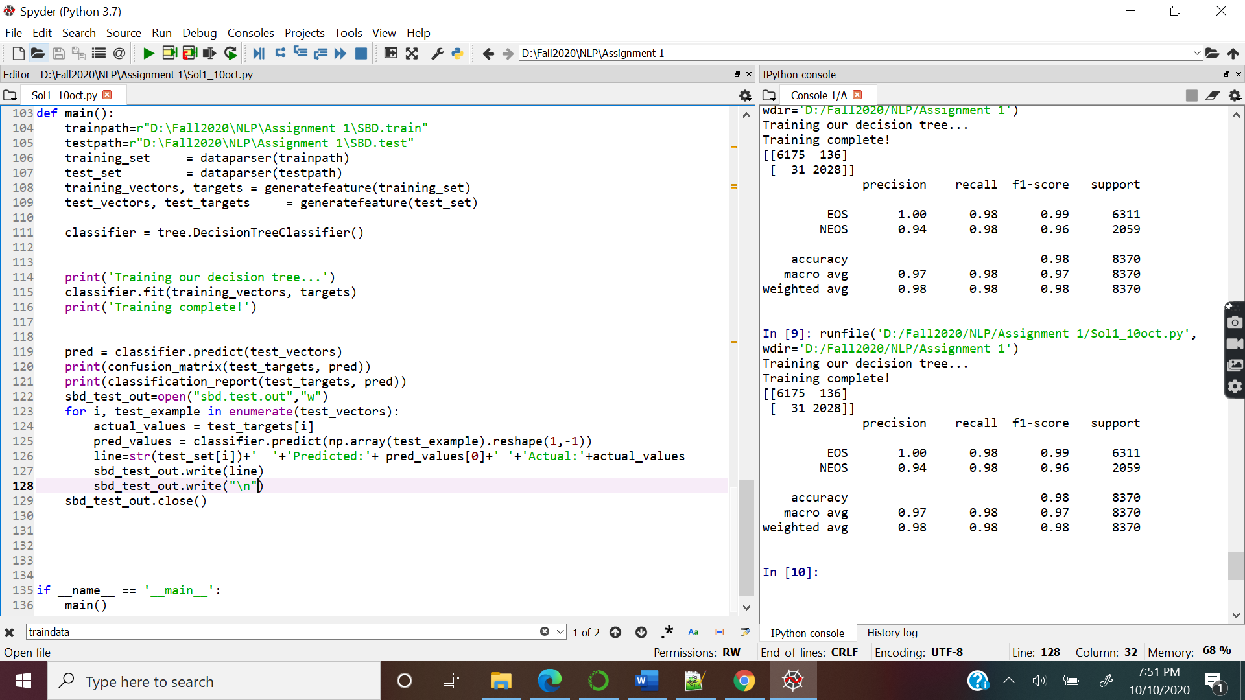

With given 5 features

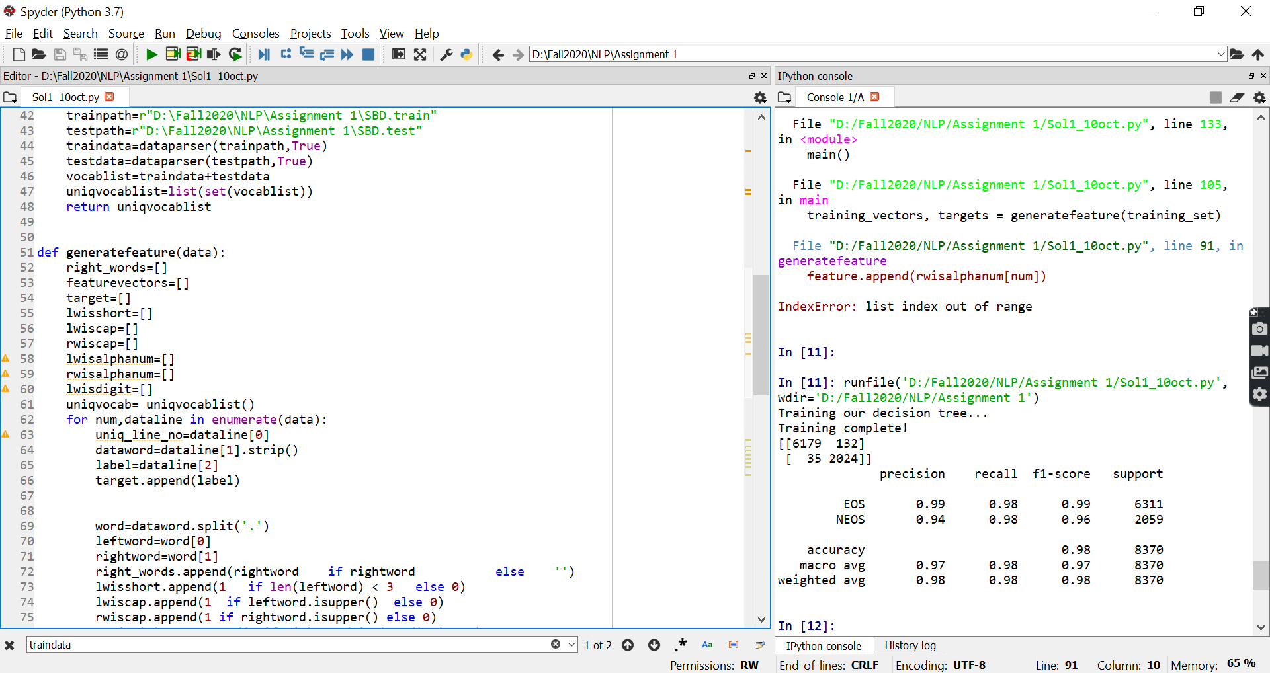

With Just 3 new features

